**Adapting to Change: The Role of Dynamic Prediction in Machine Learning**

[[Everton Gomede, PhD](https://medium.com/@evertongomede?source=post_page-----8680f6e2daef--------------------------------)](https://medium.com/@evertongomede?source=post_page-----8680f6e2daef--------------------------------)

[[AI Mind](https://pub.aimind.so/?source=post_page-----8680f6e2daef--------------------------------)](https://pub.aimind.so/?source=post_page-----8680f6e2daef--------------------------------)

[Everton Gomede, PhD](https://medium.com/@evertongomede?source=post_page-----8680f6e2daef--------------------------------)

·

[Follow](https://medium.com/m/signin?actionUrl=https%3A%2F%2Fmedium.com%2F_%2Fsubscribe%2Fuser%2Fb1a64eb107f0&operation=register&redirect=https%3A%2F%2Fpub.aimind.so%2Fadapting-to-change-the-role-of-dynamic-prediction-in-machine-learning-8680f6e2daef&user=Everton+Gomede%2C+PhD&userId=b1a64eb107f0&source=post_page-b1a64eb107f0----8680f6e2daef---------------------post_header-----------)

Published in

[AI Mind](https://pub.aimind.so/?source=post_page-----8680f6e2daef--------------------------------)

·

4 min read

·

Dec 25, 2023

78

1

**Introduction**

Dynamic prediction in machine learning (ML) refers to a methodology where predictions are continuously updated as new data becomes available. This approach is increasingly important in various fields, from healthcare to finance, where real-time data analysis and up-to-date predictions can lead to better decision-making and outcomes. In this essay, I will discuss the concept of dynamic prediction in ML, its advantages, challenges, and applications in different sectors.

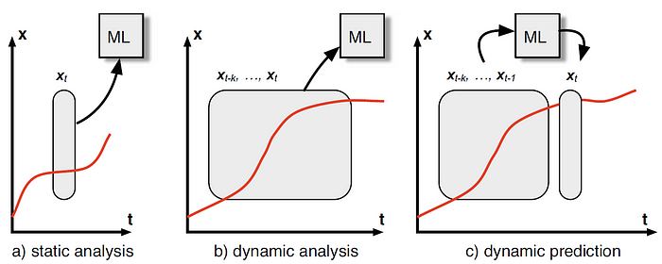

*Data is like water, ever-flowing and ever-changing; dynamic prediction is the craft that navigates these shifting currents, harnessing their power for insightful foresight.*

**Understanding Dynamic Prediction**

Dynamic prediction in ML is a process where models are not only trained on a static dataset but are continuously updated with new incoming data. This method contrasts with traditional static models, where predictions are made based on a fixed dataset, and the model does not evolve over time. Dynamic models, however, adapt to new trends, patterns, and changes in the data environment, making them more responsive and accurate in many scenarios.

**Advantages of Dynamic Prediction**

1. **Adaptability**: Dynamic models can adapt to changes in underlying data patterns, making them highly suitable for environments where data evolves rapidly.
2. **Increased Accuracy**: By continuously learning from new data, these models often provide more accurate predictions than static models.
3. **Real-Time Decision Making**: Dynamic prediction enables real-time analysis and decision-making, which is crucial in time-sensitive domains like healthcare and finance.
4. **Personalization**: In areas like recommender systems, dynamic prediction allows for personalized and up-to-date recommendations based on the latest user interactions.

**Challenges in Dynamic Prediction**

1. **Computational Resources**: Continuously updating models requires significant computational resources, which can be a challenge, especially for large datasets.
2. **Risk of Overfitting**: There is a risk that the model might overfit to recent data, losing its generalization capabilities.
3. **Data Quality and Availability:** The effectiveness of dynamic prediction is highly dependent on the quality and availability of timely data.
4. **Complexity in Model Management**: Managing and monitoring models that are continuously evolving can be more complex than dealing with static models.

**Applications of Dynamic Prediction**

1. **Healthcare**: In healthcare, dynamic prediction models can be used for real-time patient monitoring, predicting disease progression, and adjusting treatments accordingly.
2. **Finance**: In the financial sector, these models are crucial for real-time risk assessment, fraud detection, and algorithmic trading.
3. **E-commerce**: E-commerce platforms use dynamic prediction for real-time recommendation systems, adjusting suggestions based on the latest user interactions.
4. **Climate Modeling:** Dynamic models are used in climate science to make real-time predictions about weather patterns and climate change impacts.

**Code**

Creating a complete Python code example for dynamic prediction in machine learning involves several steps: generating a synthetic dataset, building a machine learning model, and then updating the model dynamically as new data comes in. For this example, we’ll use a simple regression model, but keep in mind that dynamic prediction can be applied to various types of models and more complex scenarios.

Let’s implement this in Python:

import numpy as np  
import matplotlib.pyplot as plt  
from sklearn.linear_model import LinearRegression  
from sklearn.metrics import mean_squared_error  
  
# Step 1: Generate a synthetic dataset  
np.random.seed(0)  
X = np.random.rand(100, 1) * 10 # Features  
y = 2 * X + 1 + np.random.randn(100, 1) * 2 # Targets with some noise  
  
# Step 2: Build the initial model  
model = LinearRegression()  
model.fit(X[:50], y[:50]) # Train on the first half of the data  
  
# Step 3: Update the model with new data  
mse_scores = []  
for i in range(50, 100):  
 # Update the model with one new data point at a time  
 model.fit(X[:i], y[:i])  
 y_pred = model.predict(X[:i])  
 mse = mean_squared_error(y[:i], y_pred)  
 mse_scores.append(mse)  
  
# Step 4: Visualization  
plt.plot(range(50, 100), mse_scores)  
plt.xlabel('Number of Training Points')  
plt.ylabel('Mean Squared Error')  
plt.title('Model Performance Over Time')  
plt.show()

**Explanation:**

* Synthetic Dataset: We create a dataset where y is linearly dependent on X with some added noise.
* Initial Model: We train a linear regression model on the first half of the data.
* Model Update: We then iteratively add new data points to the model, retraining it each time.
* Visualization: We plot the mean squared error over time to observe how the model’s performance changes as it gets updated with more data.

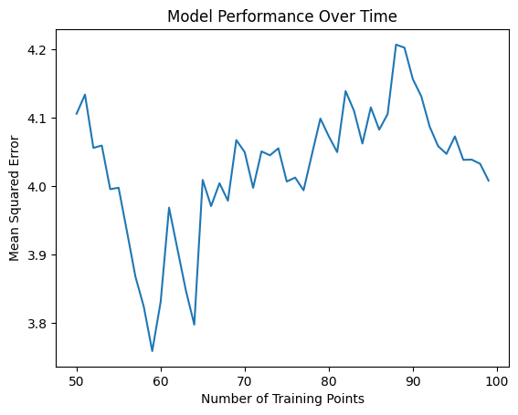

This code provides a basic framework for dynamic prediction in ML using Python. You can adapt it to more complex models and datasets as needed. Remember, the key aspect of dynamic prediction is the model’s ability to adapt and update as new data arrives.

**Conclusion**

Dynamic prediction represents a significant advancement in the field of machine learning, offering adaptability and real-time analysis that are invaluable in today’s fast-paced world. While there are challenges in implementing these models, their potential benefits in various sectors are immense. As computational resources become more accessible and techniques for handling real-time data improve, we can expect dynamic prediction to become a cornerstone in the future of ML applications.

**A Message from AI Mind**



Thanks for being a part of our community! Before you go:

* 👏 Clap for the story and follow the author 👉
* 📰 View more content in the [AI Mind Publication](https://pub.aimind.so/)
* 🧠 Improve your [AI prompts effortlessly and FREE](https://www.aimind.so/prompt-generator?utm_source=pub&utm_medium=message)
* **🧰 Discover**[**Intuitive AI Tools**](https://www.aimind.so/?utm_source=pub&utm_medium=message)